# DESIGN OVERVIEW

What are the bullet points that will sell the game?

* Character is very cute!
* It’s locally sourced!
* Our game has interesting story!

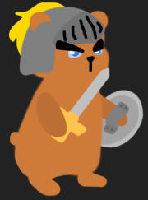

What will the rating be?

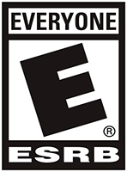

Describe/show the overall design of the game. This is the elevator pitch on a single page, preferably with art.

* Our game is Turn-based RPG game that player should beat the enemy by choosing behaviors.

Who is the target audience?

**All Age**

# COMPETITIVE RESEARCH

Show other games that are similar to yours and makes points about their relative strengths and weaknesses. Use screenshots.

**<NON-DIGIPEN GAME>**

**SLAY THE SPIRE**

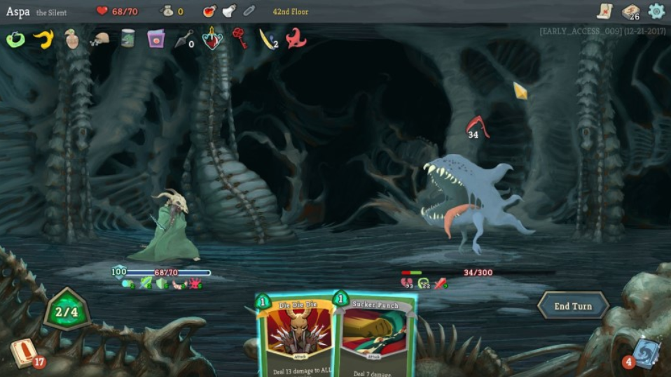

**Game Description**

"Slay the spire" is a turn-based roguelike strategy game where player use their cards to defeat the bosses. The player can get cards and powerful relics during each game plays. Each plays every player start with same deck of cards, during the game play, the player can get random cards when defeat enemies or buying from shops. The relics that gives beneficial effects to the player, and the player can get this from random encounters or defeating strong enemies. To win the game, player kill all three stratum bosses.

**Similar things**

The game is similar to our in the stages and basic concepts. The purpose of player, he/she needs to defeat all bosses.

**Strengths of this game**

One of the biggest strengths of this game is 'very well-regulated difficulty'. To clear this game belongs to a sort of difficult, but it does not mean 'cannot defeat this game', it motivates the player to keep playing this game and, give a great sense of accomplishment to the player when they defeat this game. And other strengths of this game is 'enough understanding of roguelike genre', almost all situations are set at random, but not unreasonable. The rational randomness in a roguelike is strong enough for the player makes feel 'fun' at this game.

**Weakness of this game**

It is clear that the limitation of random even though it is well rational randomness. Eventually, the player is fed up with this game. The other is the depletion of gameplay, there are few combinations of characters and cards to playing this game in a long time. the number of characters is only three, and all of the concepts of card combinations are not fully 'fun' to play it.

**<DIGIPEN GAME>**

**Game Name: The Fool**

**Game Link:** <https://arcade.digipen.edu/games/the-fool>

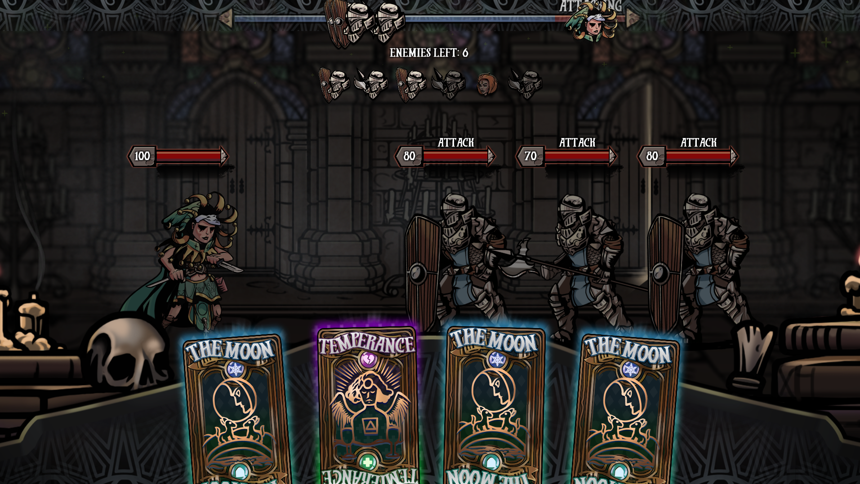

**Game** **Description**

“The Fool” is a turn-based strategy game where player use the power of the cards to beat against enemies. The cards that the player can use are randomly generated at every turn, and the player select the card and then choose which character to apply the card's effects. To win the game, the player should select the appropriate card at each turn.

**Similar things**

The game is similar to ours in that the battle is progressed by the action chosen by the player with the left mouse and that player can cancel chosen card with right mouse click.

**Strengths of this game**

One of the strengths of this game is card combination. If the player chooses two cards, it will be replaced by a card with new capabilities depending on the type of two cards selected. This widens the player's range of choices and makes him think more strategically. Another strength of this game is excellent graphic. The game has a proper background match with the characters of the game and is clean. This graphic further enhances the game's maturity and increases the player's interest.

**Weakness of this game**

The weakness of the game is its steep rise in difficulty. The weakness of the game is its steep rise in difficulty. As a matter of fact, there is no difference in the level of difficulty between the first and third stages, making it impossible to fully learn how to play the game. That's why the difficulty in the final stage embarrasses the player, even making player give up after trying a few times.

# MECHANICS OVERVIEW

Lonely Mercenary is basically a Turn-based RPG game that player choose the behaviors and items to beat the enemies. Player will choose behaviors and items by left mouse click. The battle will progress by comparing player’s chosen behaviors and enemy’s chosen behaviors.

# CHARACTER OVERVIEW

Describe/show the nature of the characters the game will have.

* **Player**

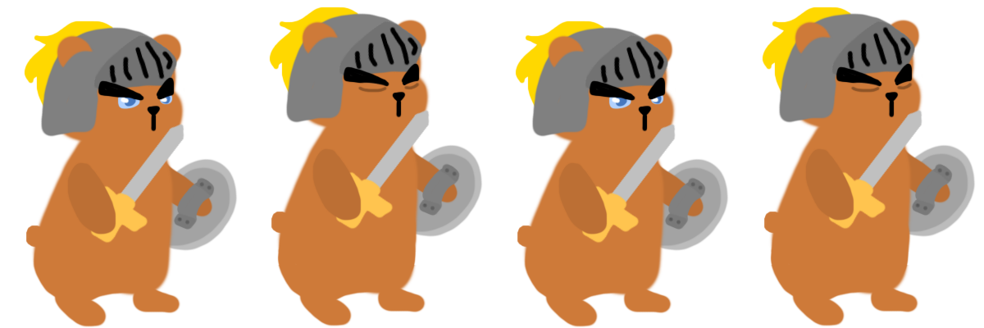

In prototype, the character of player is Beardur who is a mercenary in the shape of a bear. Beardur has stun skill as the special skill. Stun skill reduces the number of behaviors an enemy can choose from three to two in next turn. Beardur can use this special skill after 2 turn when start. Also, this skill can be used after 2 turn when use this skill.

* **Enemy**

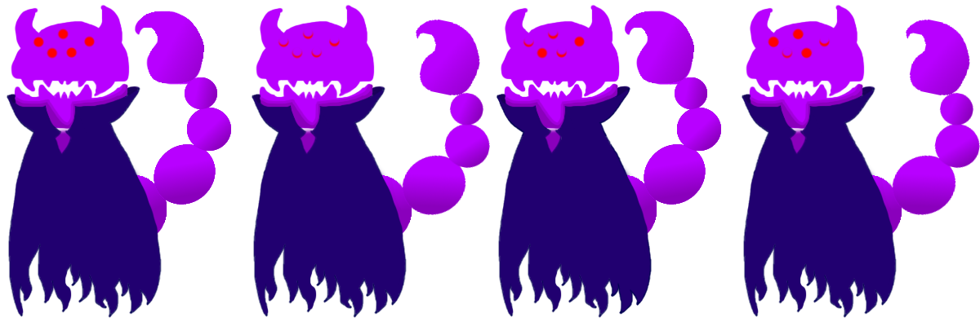

In prototype, the character of enemy is Vampion who has the shape of a scorpion. Vampion has blood sucking skill as the special skill. This skill takes the 30% of player’s health from player. Vampion can use this special skill after 2 turn when start. Also, this skill can be used after 2 turn when use this skill.

# RESOURCES OVERVIEW

All of art resources that we used in game is our own made resources. The format of all of arts that we used in game is .png format.

* **Character**

Beardur_Normal.png

Vampion_Normal.png

* **Behaviors**

attack.png

defense.png

special.png

Card_1.png

Card_2.png

Card_3.png

question_mark.png

* **Effect**

BloodSucking.png

Stunned.png

* **Background**

Background.png

* **UI**

play.png

how_to_play.png

credit.png

UI.png

rectangle.png

* **Icon**

icon.png

* **Logo**

Logo.png

Team_logo.png

All of audio resources that we used in game are from third party. The formats of audios that we used in-game are ogg, wav and mp3 format.

* **Background Music**

Battle_BGM.ogg

* **Sound Effect**

Card_select.wav

Team_Logo_horse.mp3

# ENVIRONMENTS OVERVIEW

Our game is consisting of various stages which have enemies and background music to match the theme of each stage. For example, when the player reaches the cyber stage, the background of the stage will change to grid pixels and the background music will changes to 8-bit music. Even though the story of our game (reference narrative overview part) is serious, the background design and character design of each stage is neat and cute. So, our game won't give the player a heavy atmosphere.

# NARRATIVE OVERVIEW

**GAME STORY**

The world was so peaceful. But one day, a devil king was born, and many people were robbed or killed. The number of kidnappings and disappearances has also increased. At this time, in order to save the world, our "Beardur" began to adventure to capture the devil king! To capture the devil king, "Beardur" collected money by kill the monsters and bought weapons and items from various villages. Will “Beardur” ever win the devil king and restore peace?

# ART OVERVIEW

Describe/show the nature of the art the game will have.

The overall art style is cute. Even though our game has a serious story, we didn't want the player to take our game seriously. Also, the most important purpose of our team art is intuition. So, we made art resources as simple and neat as possible.

* **Character**

 

We designed the character so that the player could see what it described. Also, we designed characters so that players can guess what special skill they might have by just looking at the design of the character. The second picture, “Vampion”, is a very good example. This character has sharp fangs and dressed as Dracula. So, the player can infer that this character's special skill may be related to vampires.

* **Behaviors**

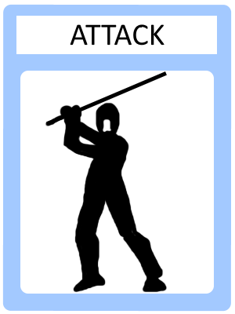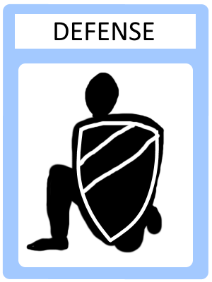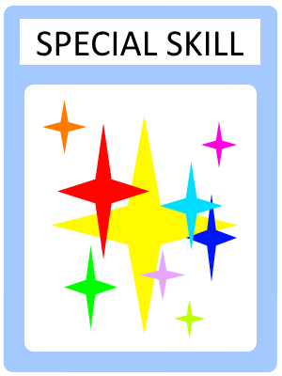

We wanted to make behavior art to make player can understand the situation intuitively. So, we made behavior art as simple and neat as possible.

* **Effect**

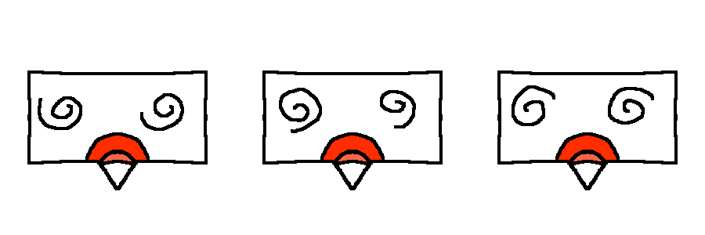

We wanted to make effect art to make player can understand intuitively what’s going on when character use special skill. So, we made effect art as simple and intuitive as possible.

* **Background**

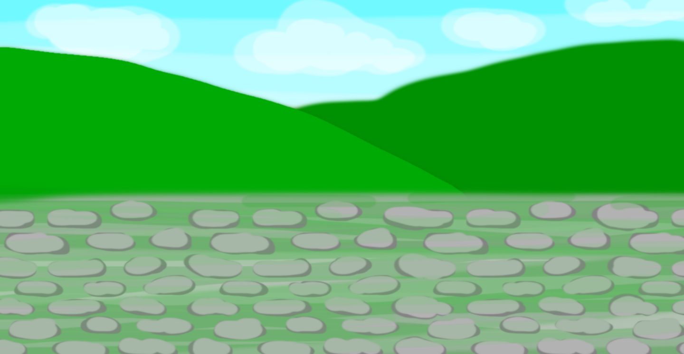

In our game, the background will be different depending on the stage. Thus, the background screen will be made with various tools like painting tool and pixel. All background screens will be created with a refreshing feel, such as the background screens used in the prototype, to avoid giving the player too much of a serious impression.

# AUDIO OVERVIEW

Describe/show the nature of the audio the game will have.

* **Background Music**

Our game has various stages. So, the nature of the background music will be changed depending on each stage. For example, if the player reaches the cyber stage, the background of the stage will change to 8-bit music. In the prototype, to make the player focused on the battle, we chose music that was both serious and tension-boosting.

* **Sound Effect**

We will use a variety of sound effects in the game to make the player intuitively aware of what is happening. For example, when “Vampion” (enemy) use blood sucking (special skill), the sound effect of sucking will play. In prototype, even though we only have 1 sound effect which play when player choose behaviors, we will add more proper sound effects to make the player intuitively aware of what's going on.

# INTERFACE OVERVIEW

Show/describe the nature of the controls/HUD for the game.

* **Main Menu**

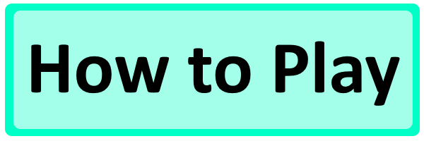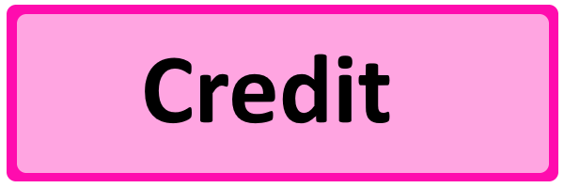

This picture is the UIs which used for main menu. These UIs work by left mouse click. First UI is Play UI that player can play the game by clicking. Second UI is How to play UI that player can go to the page where you can get the information you need to play the game by clicking. Third UI is Credit UI that player can go to credit page that contains copyright, people who helped us, etc.

* **In Game Interface**
  + **Select UI**

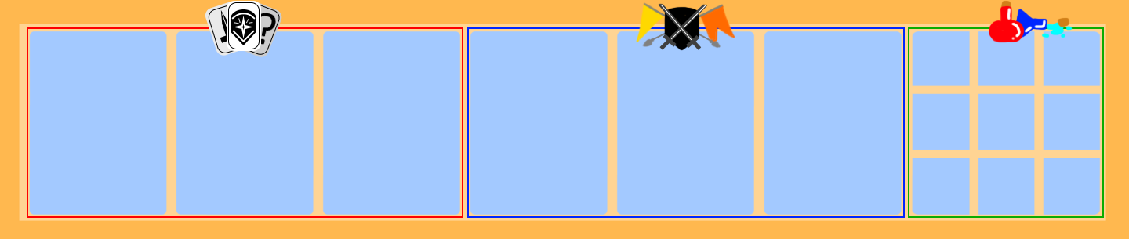

This picture is the select UI, which is located under of the screen, shows the behaviors, weapons and items. Players can use behaviors, weapons, and items by clicking the UI space with right mouse.

**Behavior Space Weapon Space Item Space**

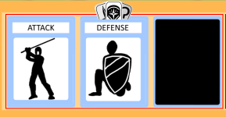 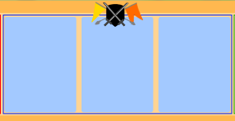 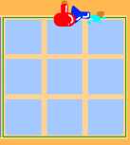

The select UI is divided into 3 spaces. First space is behavior space shows 3 behaviors that player can choose for battle. The black image of third space is the space for special skill which player can choose after every 2 turn. This black image will change to special skill image when after 2 turn. Second space is weapon space that shows 3 weapons that player can use for battle. Third space is Item space that shows items that player can use for battle.

* + **Player Behavior UI**

 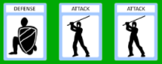

This picture is the player behavior UI, which is located top of the player character, shows the player’s chosen behaviors. When player didn’t choose behaviors, this UI will show images like first picture. However, when player choose behaviors, this UI will show player’s chosen behavior image like second picture.

* + **Enemy behavior UI**

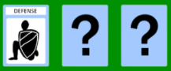 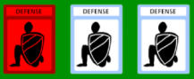

This picture is the enemy behavior UI, which is located top of the enemy, shows the enemy’s chosen behaviors. This UI shows only the first behavior the enemy chooses before the battle begins like first picture. However, as soon as the battle begins, it shows all the actions the enemy chooses like second picture.

* + **Health UI**

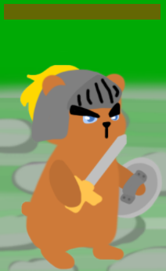

This picture is the health UI, which is located top of each character, shows each character’s remaining health.